* ***Question 1:* Make an inline function. Plot it using vectors and. What is wrong with this graph?**
* ***Answer:*** From the figure, we see there is a problem or wrong in the middle part of the graph. In this graph, first part and the second part of the graph are similar. But, in the middle part of graph, there is some part increasing and it stays upper level. After some plot, we see that the graph match again with the fast part. This is a wrong part in this graph.

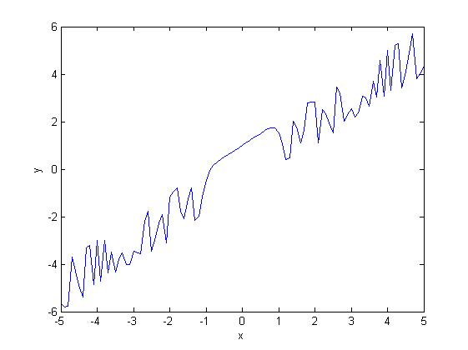

**Figure: 1**

* ***Question 2:*** **Determine the value of the expression, where  and .**
* ***Answer:***

a=2;

b=3;

c=-4; **and final result or output is Result = 28**

d=-3;

x=b+c;

y=c+d;

sum=x*y;

sum1=sum*a;

Result=sum1*a

* ***Question 3:*** **Use MATLAB to calculate the expression  where.**
* ***Answer:***  a=3;

b=5;

c=-3;

x=b+a;

y=c*a; **and final result or output is Result = 4.2703**

z=x/y;

sum=b+z;

sum1=a/sum;

Result=b-sum1

* ***Question 4:*** **Calculate the expressions:,, , ,  and .**
* ***Answer:***

value_of_sin=sin(2*pi/6)

double expand(ln(4))

value_of_cos=cos(pi/3)

value_of_negative_sin=sin(-2*pi/6)

a=cos(pi);

double expand(2+a);

double ln(expand(2+a))

s=tan(pi/6)

s1=tan(pi/4)+tan(pi/3)

Division=s/s1

**and final result or output is:**

value_of_sin =

0.8660

ans =

101 120 112 97 110 100 40 108 110 40 52 41 41

value_of_cos =

0.5000

value_of_negative_sin =

-0.8660

ans =

Columns 1 through 13

108 110 40 101 120 112 97 110 100 40 50 43 97

Columns 14 through 15

41 41

s =

0.5774

s1 =

2.7321

Division =

0.2113

* ***Question 5:*** **Create two vectors running from one to six and from six to one. Then find the addition, subtraction, multiplication, division and exponential of two.**
* ***Answer:***

a=1:6;

b=6:-1:1;

Addition=a+b

Subtraction=a-b

Multiplication=a.*b

Division=a./b

Exponential_of_a=a.^2

Exponential_of_b=b.^2

Final result or output is:

Addition =

7 7 7 7 7 7

Subtraction =

-5 -3 -1 1 3 5

Multiplication =

6 10 12 12 10 6

Division =

0.1667 0.4000 0.7500 1.3333 2.5000 6.0000

Exponential_of_a =

1 4 9 16 25 36

Exponential_of_b =

36 25 16 9 4 1

* ***Question 6:*** **Set up a vector which contains the values from zero to one in steps of one tenth.**
* ***Answer:***

x = 0 : 0.10 : 1;

y=linspace(0,1,10);

Result=y

**and final result or output is:**

Result =

Columns 1 through 8

0 0.1111 0.2222 0.3333 0.4444 0.5556 0.6667 0.7778

Columns 9 through 10

0.8889 1.0000

* ***Question 7:*** **Construct the polynomial for values of  from minus one to one in steps of .**
* ***Answer:***

x=-1:0.1:1;

f=x+2;

g=f.^2;

h=x.^3+1;

y=g.*h;

Result=polyval(y,x)

Final result or output is:

**Result =**

Columns 1 through 8

9.8960 10.4271 10.9457 11.5095 12.1338 12.8297 13.6107 14.4933

Columns 9 through 16

15.4989 16.6554 18.0000 19.5833 21.4765 23.7832 26.6610 30.3642

Columns 17 through 21

35.3347 42.4193 53.4350 72.7590 111.9664

* ***Question 8:*** **Construct the function  for values of  from one to two in steps .**
* ***Answer:***

x = 1:0.01:2;

f=x.*x; **and final result or output is Result=0.4811**

y=f.*x+1;

Result=f/y

* ***Question 9:*** **Construct the function  for values of  from one to three in steps of **
* ***Answer:***

x = 1:0.02:3;

i=cos(x);

j=x.*i; **and final result or output is y =-0.1079**

z=x.*x+3.*x+1;

k=j/z;

y=sin(k)

* ***Question 10:*** **Plot the polynomial  between  and .**
* ***Answer:***

x=linspace(-2,2,50);

c=[1 0 1 0 -1];

y=polyval(c,x);

plot(x,y)

xlabel('x')

ylabel('y')

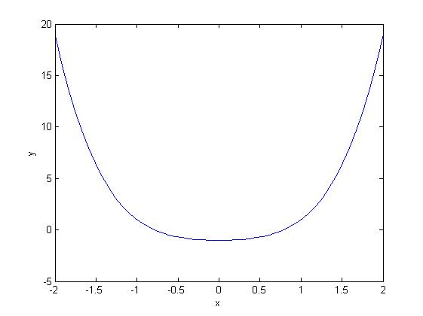

**Figure: 2**

* ***Question 11:*** **Find the size of an array. [Hints : size(x)]**
* ***Answer:***

x=linspace(-2,2,50);

size(x); **and final result or output is Result = 1 50**

Result=size(x)

* ***Question 12:*** **Construct the function  as a inline function on the set of points  to in steps of and give the value of f(x) at ,  and .**
* ***Answer:***

x=0:0.2:2;

f = inline('x.^2+2','x');

f(x);

f(0)

f(1)

f(2)

**and final result or output is:**

ans =

2

ans =

3

ans =

6

* ***Question 13:*** **Extract the various parts of the array  such as extract the whole of x, first half of x, and even indices only.**
* ***Answer:***

x = linspace(0,1,10);

y1= x(1:end)

y2= x(1: end/2)

y3= x(2:2: end)

y4= x(2: end-1)

**and final result or output is:**

y1 =

Columns 1 through 8

0 0.1111 0.2222 0.3333 0.4444 0.5556 0.6667 0.7778

Columns 9 through 10

0.8889 1.0000

y2 =

0 0.1111 0.2222 0.3333 0.4444

y 3=

0.1111 0.3333 0.5556 0.7778 1.0000

y 4=

0.1111 0.2222 0.3333 0.4444 0.5556 0.6667 0.7778 0.8889